Here you will be taught how to make a 3D grid.
1) Open a new file, around 450 x 350 pixels, with any background color. I used black.
2) Open another file. 20 x 20 pixels with a transparent background and using the pencil tool do this. I zoomed in to 1600% that’s why its looks so big. Make the white thickness about 3 pixels on the top and left side.
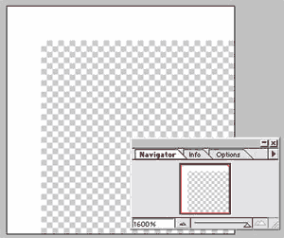
3) Still on the 20 x 20 file, go to SELECT > ALL
4) Go to EDIT > DEFINE PATTERN.
5) Now click on the original file, the one with the black background. Make a new layer.
6) Go to EDIT > FILL. This box will popup.
Make sure you have USE set to PATTERN.

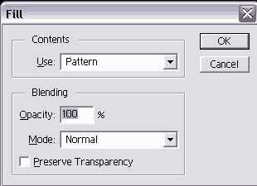
Here is what you should get.
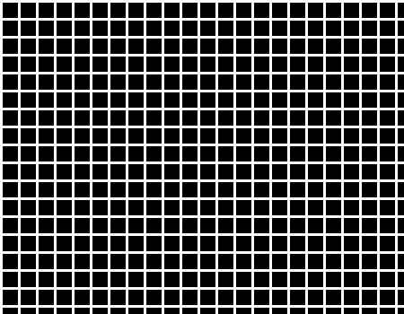

7) Using the rectangle Marquee tool select a area that makes a complete square. Cause we don't want to have incomplete edges in our grid like the right and bottom side are now.
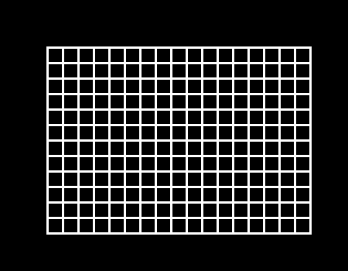
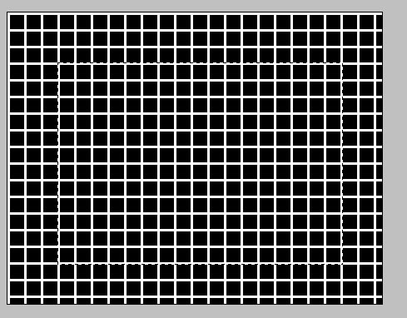
8) Go to SELECT > INVERSE. then hit the delete button. Your grid should look like this.

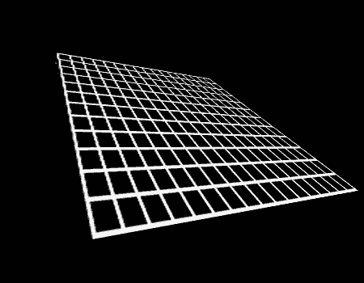

9) Now on the Grid layer, go to EDIT > TRANSFORM > PERSPECTIVE. Just play
around until you get what you want. Heres mine.

Burnt Paper Edges

The following tutorial will teach you how to create burnt edges on a picture -- only you won't have to use matches this time!
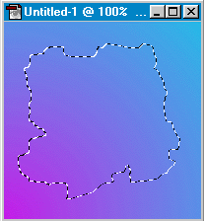
1. Open the image you want to use, or create a new document. If you're starting a new image, let's give it some color by making a diagonal gradient with the Gradient Tool (see example). Using the Lasso Tool, create a semi-round selection with jagged edges: to make it more realistic, drag the lasso tool slowly while moving your hand up & down, left & right.

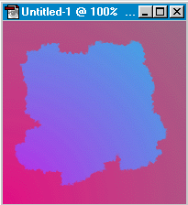
2. Switch to Quick Mask Mode and use Filter-> Pixelate-> Crystalize with setting of 3.

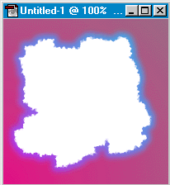
3. Switch back to Standard Mode and save the selection (Select-> Save Selection). After pressing OK, fill the selection with white (Edit-> Fill) or whatever other color your heart desires. Then choose Select-> Modify-> Expand. You can enter 4 or 5 (depending how big edge you want). Now, switch to Quick Mask Mode again and choose Filter-> Blur-> Gaussian Blur with setting of 3.

4. Now, go back to Standard Mode and choose Select-> Load Selection and make sure your saved selection (should be called Alpha 1 or #4) is selected in the Channel dropdown. Check Subtract from Selection and press OK.
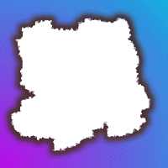
5. Time for some color! Choose, Image-> Adjust-> Hue/Saturation and click the Colorize check box. Set the Hue to 14, Saturation to 31 and Lightness to -61 (or adjust to your preference). Tah Dah!

Cool Dots

Step 1: Getting Started
Create a New File

Step 2: Creating a New Channel
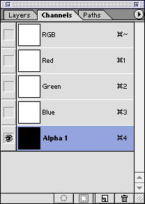
- In the channels palette click the Create New Channel button.
- You can accept the default name of Alpha 1.

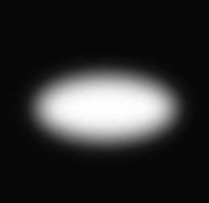
Step 3: Creating an Ellipse
- Make an Oval Selection using the Elliptical Marquee Tool.
- Fill with white.
- Deselect by clicking Commmand-D/Control-D
- Blur by going to Filter>Blur>Gaussian Blur. I used 12 but experiment.

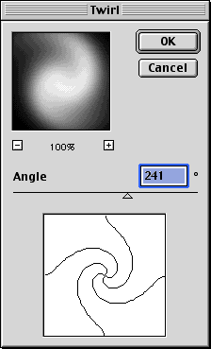
Step 4: Adding the Distortion
Go up to Filter>Distort>Twirl

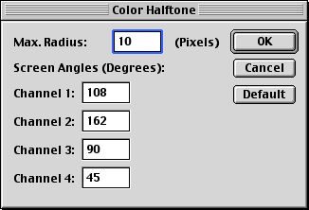
Step 5: Applying the Color Halftone Filter
- Filter>Pixelate>Color Halftone
- I used a Max Radius of 10 but as you experiment with different shapes and sizes you'll want to also experiment with these settings

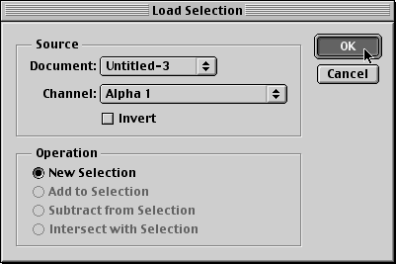
Step 6: Loading the Selection
- Return to the Layers Palette and create a new layer Layer>New Layer
- Load the selection
- Go up to Select>Load Selection and load Alpha 1 from the drop down menu

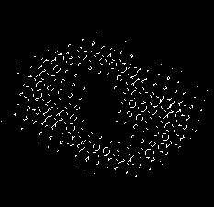
Step 7: Making the Background Color
- Fill the selection with the foreground color by going to Edit>Fill... and choose Foreground Color from the Contents option in the popup window
- Deselect by going up to Select>Deselect or click Command-D/Control-D
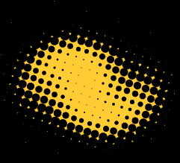

Here you will be taught how to make ice.

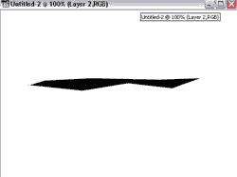
1)Open a new file, around 400 x 300 pixels. with a white background.
2) Use the lasso tool and make the shape you want your ice to look like. Make it black.

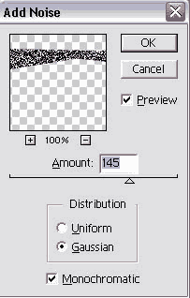
3) Go to FILTER > NOISE> ADD NOISE
Use these setting
4) Go to FILTER > PIXILATE > CRYSTALLIZE
Use between 2-4.
5) Go to FILTER > STYLIZE > FIND EDGES
6) Go to FILTER > BLUR > GUASSIAN BLUR
Set it to about 1.
7) Go to IMAGE > ADJUST > INVERT
8) Go to EDIT > TRANSFORM > ROTATE 90 CW
9) Go to FILTER > STYLIZE > WIND
For the setting use WIND and make it either left or right, depending on what side you
want the icicles hanging off.

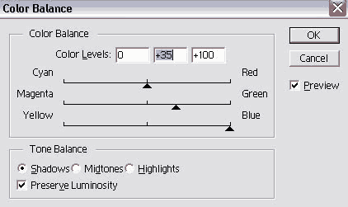
10) Rotate it back the the way you had it before. Go to IMAGE > ADJUST >
COLOR BALANCE
use these settings

11) Go to IMAGE > ADJUST > HUE/SATURATE
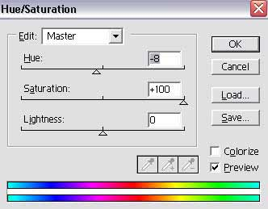
12) You can use different setting on the last 2 steps to make it any color your want
Thats it. here my final result.
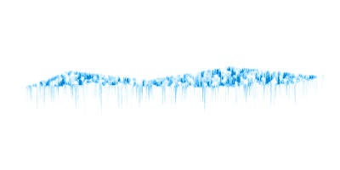

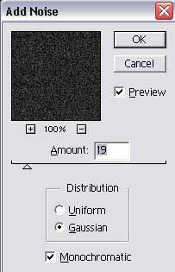
Here you will be taught how to make a metal Texture.
1) Open a new file, around 450 x 350 pixels and make it transparent.
2) Pick a gray/dark gray color and set it as the background color.
3) Go to FILTER > NOISE > ADD NOISE and use these settings.

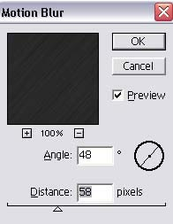
4) Go to FILTER > BLUR > MOTION BLUR and use these settings.

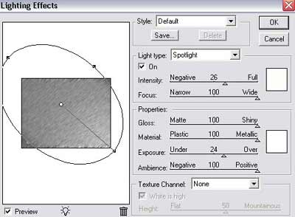
5) Now go to FILTER > RENDER > LIGHTING EFFECTS and use these settings

Heres my results
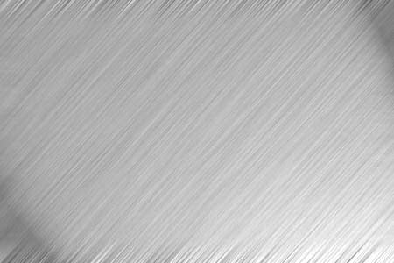
and with a little more work we get this.
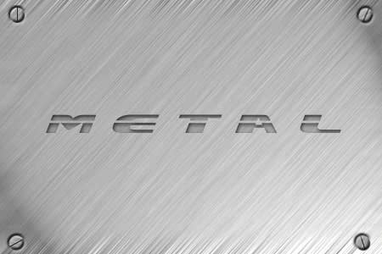

Blending 2 Images Smoothly Together
Well here you will be taught how to blend 2 images smoothly together.
1) Get 2 pictures that you want to blend together. These are the 2 i used:
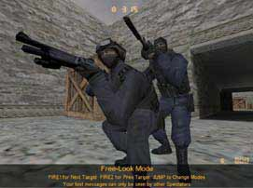 | 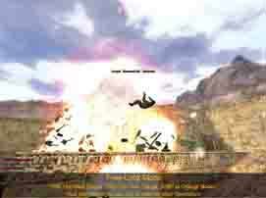
2) Next put each picture on its own layer putting the picture u want blending on the top. Then using the rectangle marquee tool on the top layer, make a rectangle selection of what u want blended. Here is what i choose.
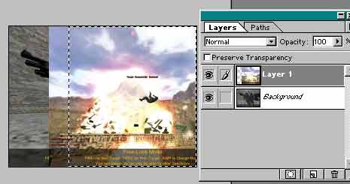
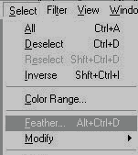
3) Now go to SELECTION>FEATHER. A box will pop up. this will determine come much the pictures will blend together. I choose 30 for mine.

4) Now make sure the rectangle that u made in the beginning is still there. And hit Clrl + C (copy). This will copy the top image. now click Clrl + V (paste) this will paste the top picture into the feathered rectangle.
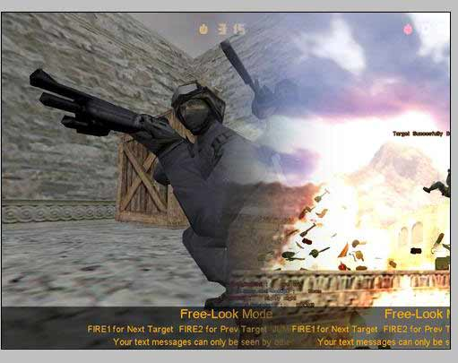
EXTRA
You can also get similar results using the Eraser Tool and using a very large brush size. just make sure the pic you want to blend into the background is on top.
